**CL24.42 Nebraska Estate, St Georges Basin - Planning Proposal (PP) Options**

**HPERM Ref:** D23/496054

**Department:** Strategic Planning

**Approver:** Coralie McCarthy, Acting Director - City Futures

**Attachments:** 1. Rezoning Option Maps - Councillor Briefing

2. Tenure Resolution Feasiblity - Nebraska Rezoning Options (councillors information folder)

Reason for Report

*[compulsory]*

The purpose of this report is to seek direction and endorsement to progress a Planning Proposal (rezoning) to resolve the Nebraska Estate ‘paper subdivision’ at St Georges Basin.

|  |
| --- |
| Recommendation  *[compulsory - Structure the recommendation so that it stands alone when included in the minutes or any other document. Recommendations should NOT be of the kind “That the matters outlined in the report be adopted”.]*  That Council:   1. Update the Nebraska Estate Planning Proposal (PP) based on Option 3.1 as outlined in this report, noting that timing will also depend on workloads generated by proponent-initiated PPs. 2. Submit the updated PP to the Department of Planning, Housing and Infrastructure (DPHI) for a Gateway determination. 3. Subject to receiving a favourable Gateway determination from DPHI, exhibit the PP package. 4. Prepare a draft site-specific chapter (Chapter N9 - Nebraska Estate) for inclusion in the Shoalhaven Development Control Plan (DCP) 2014, acknowledging that staff resources available to work on this project will depend on workloads associated with proponent-initiated PP’s and other strategic planning priorities. |

Options

*[compulsory]*

1. Update the Planning Proposal (PP) based on Option 3.1 and seek a Gateway determination. This is the recommended option.

Implications: This option balances the concerns raised by Councillors at the meeting on 17 July 2023 (MIN23.361) with the need to bring this complex legacy planning matter to a conclusion. The PP would facilitate 17 new dwellings on the least constrained land and rezone the more environmentally sensitive land for conservation. The tenure of the residual C2 land could potentially be resolved using the net profits from Council’s developable land, following the principle underpinning Council Policy [POL23/18](https://doc.shoalhaven.nsw.gov.au/Displaydoc.aspx?Record=POL22/43).

This option utilises the extensive body of work that has been completed over many years and funded by the landowners. Subject to receiving a favourable Gateway determination from the Department of Planning, Housing and Infrastructure (DPHI), community feedback would be sought on the PP and draft DCP and presented to Council for consideration. Discussions with the DPHI indicate that a local clause could potentially be utilised that requires a DCP and essential road infrastructure to be in place before development can be approved. This will enable the DCP finalisation, infrastructure, and financial planning tasks to be completed in a logical and manageable sequence, after the zoning has been resolved.

1. Progress the Nebraska Estate PP based on a different option.

Implications: An option for allowing up to 23 new dwellings was reported to Council on 17 July 2023 was not supported by Council due to a range of concerns. This report includes information on the options presented to a Councillor briefing on 28 September 2023. Further advice on the options can be provided if required.

Background

*[compulsory – Provide a brief background to the topic, why council resolution is required and further detail in relation to the options]*

Council considered a report on the Nebraska Estate PP on 17 July 2023 that provided a range of background information. The report and its attachments can be viewed via the following links:

* [Report to Ordinary Meeting 17 July 2023 (CL23.214)](http://doc.shoalhaven.nsw.gov.au/Displaydoc.aspx?Record=D23/190868)
* [Attachment 1:](http://doc.shoalhaven.nsw.gov.au/Displaydoc.aspx?Record=D23/235407) [Draft Planning Proposal - Nebraska Estate, St Georges Basin](http://doc.shoalhaven.nsw.gov.au/Displaydoc.aspx?Record=D23/235407)
* [Attachment 2:](http://doc.shoalhaven.nsw.gov.au/Displaydoc.aspx?Record=D23/253497) [Updated Constraints Summary Map (2023)](http://doc.shoalhaven.nsw.gov.au/Displaydoc.aspx?Record=D23/253497)

The July 2023 report sought Council’s ‘in principle’ support to restart the PP process for the Estate based on an updated version of a concept plan adopted by Council in 2016.

Council resolved to:

“… *defer consideration … to enable Council to be fully briefed on:*

* 1. *The possible expansion of the proposed C2 Environmental Conservation zone to the whole of the subject land, or parts of it, to afford greater protection to the Estate’s environmental values and Jervis Bay wildlife corridors, and*
  2. *Minimise the creation of areas of isolated development in bushland that are at risk from bushfire and may incur large infrastructure maintenance costs per capita*.”

The resolved briefing was held on 28 September 2023 and attended by six Councillors. The following options were presented and discussed at the briefing:

1. **Option 1** – enabling up to potentially 23 new dwellings and rezoning the Estate to a mix of *C2 Environmental Conservation*, *C4 Environmental Living* and *R5 Large Lot Residential.* Based on 2016 concept plan with some minor changes/adjustments.See **Figure 1**.
2. **Options 2.1 or 2.2** - no new dwellings, rezoning the whole Estate to C2 (**Option 2.1**) with a variation of rezoning the cleared land west of Waterpark Road to R5 (**Option 2.2**).
3. **Options 3.1 and 3.2** - reduced overall development footprint enabling up to either 17 new dwellings (**Option 3.1** – see **Figure 2**) or 16 dwellings (**Option 3.2**) and rezoning the Estate to a mix of C2, C4 and R5.

Options 1 and 3.1 are shown below in **Figures 1** and **2** respectively given Councillors’ interest in these options at and following the briefing.

Maps of all options are provided in **Attachment 1**.

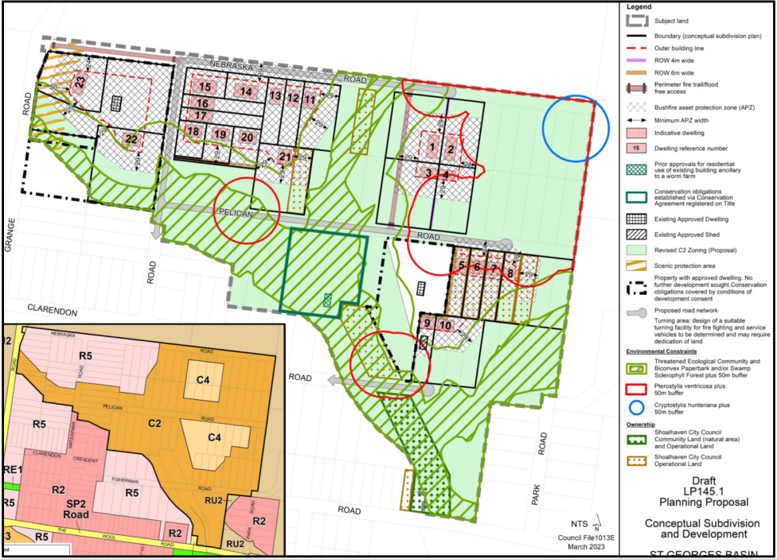

**Figure 1**: Option 1 concept plan (main) and zoning (inset) – 23 dwellings

**Figure 2**: Option 3.1 concept plan (main) and zoning (inset) – 17 dwellings

Follow-up information was circulated following the briefing to Councillors on 27 October 2023, including a preliminary feasibility assessment of applying the tenure resolution model which underpins the existing Council Policy [POL23/18](https://doc.shoalhaven.nsw.gov.au/Displaydoc.aspx?Record=POL22/43) – essentially using the net profits from the sale of Council’s developable land to purchase (voluntary purchase only) and manage the residual C2 land.

The feasibility of resolving the tenure of the residual C2 land for each option is ranked from highest to lowest below.

1. **Option 1** is the **most feasible** (even if 100% of the residual C2 land is acquired).
2. **Option 3.1** is the **next most feasible** to resolve tenure. An acquisition price of around $30,000 per lot would enable >75% of residual C2 properties to be acquired and managed.
3. **Option 3.2** is **less feasible than Option 3.1** but still potentially viable.
4. **Option 2** (2.1 and 2.2) there would be no ability to resolve land tenure. Ownership would become more fragmented over time (if or when lots within multiple landholdings are individually sold).

The feasibility information circulated to Councillors on 27 October is available in the Councillors information folder.

Internal Consultations

*[optional heading – consider internal consultation – delete if not required]*

Options 2 and 3 were developed in consultation with Council’s Land Management team. [POL23/18](https://doc.shoalhaven.nsw.gov.au/Displaydoc.aspx?Record=POL22/43) (*Voluntary Acquisition – Residual C2 Environmental Conservation Land – Jerberra & Nebraska Estates*) was developed in consultation with Councils finance, property, and land management staff.

External Consultations

*[optional heading – consider external consultations – delete if not required]*

Key NSW Government agencies have been consulted on the planning options over the years, including the former NSW Department of Planning and Environment, former Biodiversity Conservation Division, and Rural Fire Service.

Further agency consultation would occur should Council decide to progress the PP.

Community Consultations

*[optional heading – consider community consultation – delete if not required]*

The Estate’s landowners have been consulted and informed through this long running matter. Several landowner workshops and surveys have been conducted in previous years. In recent years, letters have been sent to landowners when appropriate (e.g. prior to relevant Council meetings).

If a PP is ultimately progressed, landowners and the broader community will be formally engaged as part of the public exhibition process (post Gateway).

Policy Implications

*[optional heading – consider current council policies related to the matter and the impact the recommendation & options may have. – delete if not required]*

On 5 October 2021, Council adopted a Policy titled ‘[Voluntary Acquisition – Residual C2 Environmental Conservation Land - Jerberra & Nebraska Estates](https://doc.shoalhaven.nsw.gov.au/displaydoc.aspx?record=POL21/44)’ ([POL23/18](https://doc.shoalhaven.nsw.gov.au/Displaydoc.aspx?Record=POL22/43)). Part 4 of the resolution to adopt the Policy (MIN21.699) included the following note:

1. *The Policy will also* ***only apply to land in the Nebraska Estate, St Georges Basin if/when the Planning Proposal (LP145.1) for the Estate has been finalised and the land rezoned*** [emphasis added] …

The Policy will need to be reviewed and updated if the Estate is rezoned.

Financial Implications

*[optional heading] [include budget comments if required, do we have the funds and resources to do what is being recommended? – delete if not required]*

Costs associated with preparing the PP (including the supporting studies) were funded by a $200,000 Council loan that was repaid by the benefitting landowners over 10 years through special rates.

$32,777 remains unspent and is available to assist this project and should be sufficient to complete the rezoning process provided the matter is not deferred. A preliminary contamination assessment would need to be completed. This was quoted at $11,425 +GST in August 2023.

Any funds remaining at the conclusion of the PP process are intended to be utilised for designing the necessary upgrades to the subdivision infrastructure, for which a new special rate (or equivalent funding arrangement) will be required.

Risk Implications

*[optional heading – delete if not required]*

Work completed since 2005 was funded by the landowners via special rates collected over 10 years. While Council has no legal obligation to restart the PP process, a decision not to would trigger a strong reaction from the Estate’s landowners, who have a reasonable expectation that the Estate’s planning status will be resolved one way or another.

In the meantime, speculation about the land’s rezoning potential will continue to influence sales. If the Estate’s planning future is not resolved now, the area will continue to be impacted by unauthorised clearing, development, and other activities.